Ranks and Addressing – Adults

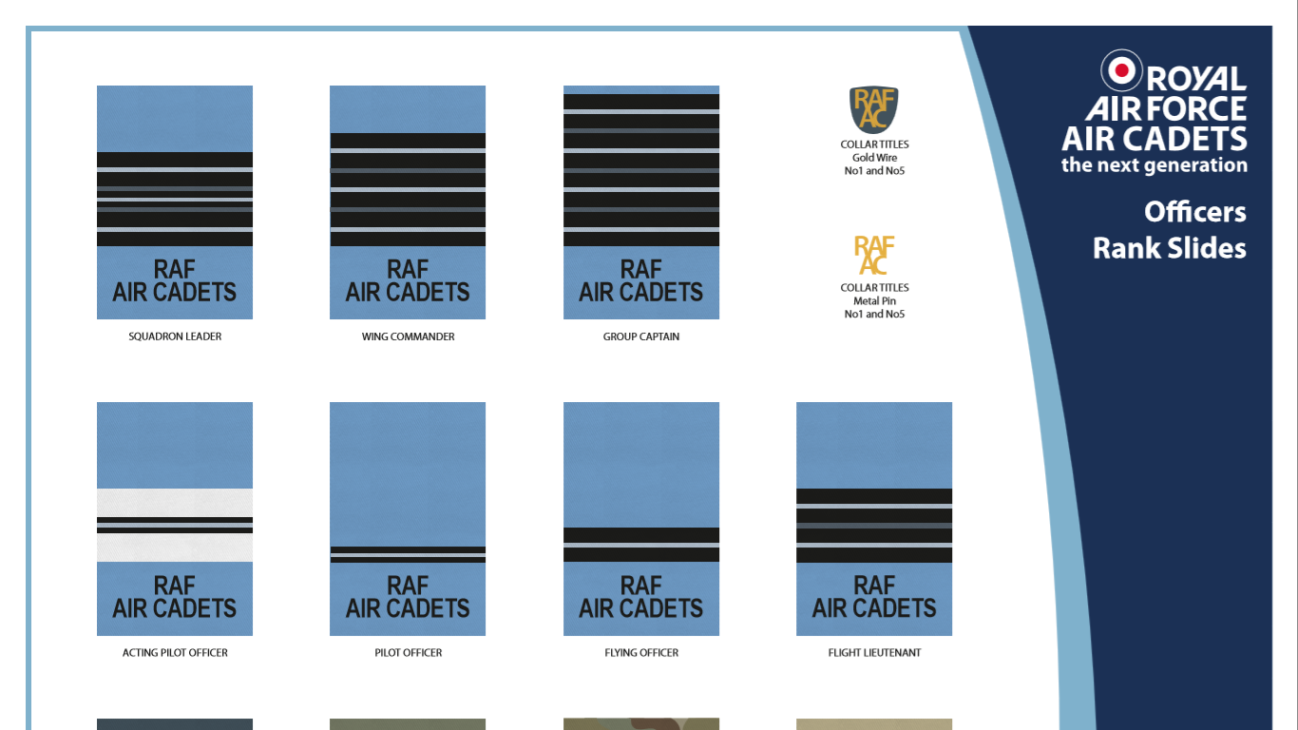Commissioned Officer



Salute

Acting Pilot Office Pilot Officer Flying Officer Flight Lieutenant Squadron Leader Wing Commander Group Captain

“Sir” or “Ma’am”

Non-Commissioned Officer Non-Commissioned Officer Aircrew

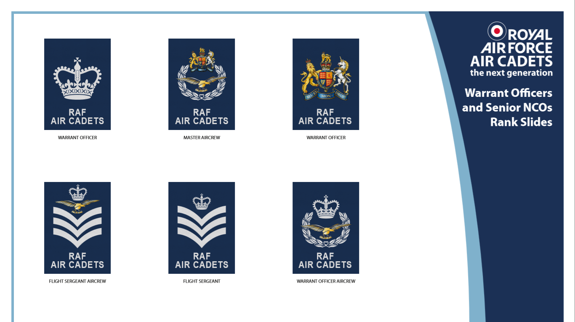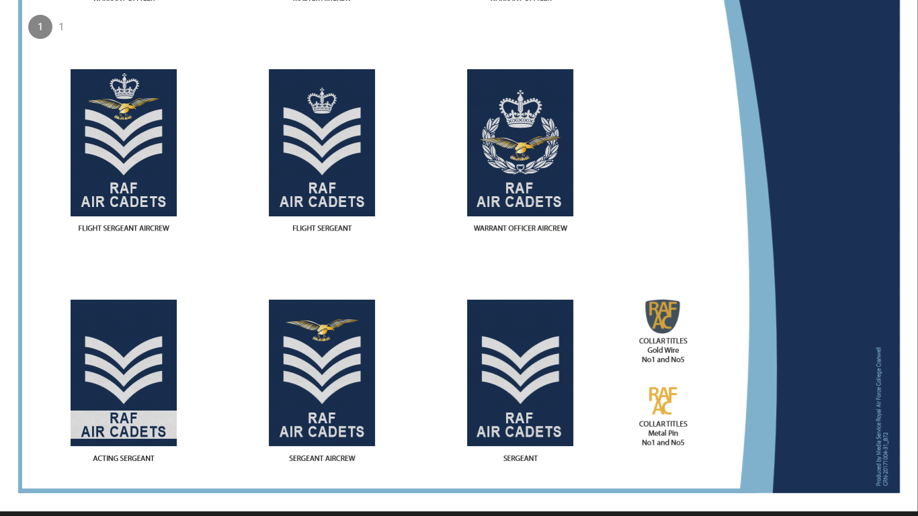



Stand to attention

Warrant Officer Warrant Officer Warrant Officer Aircrew

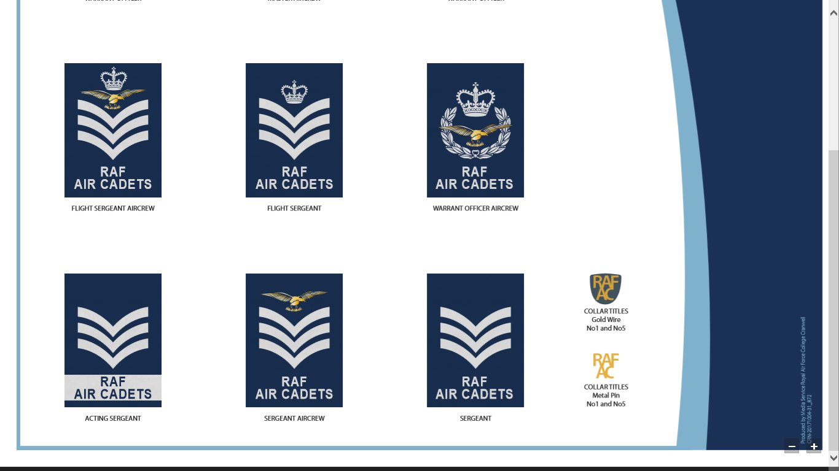

“Flight Sergeant”

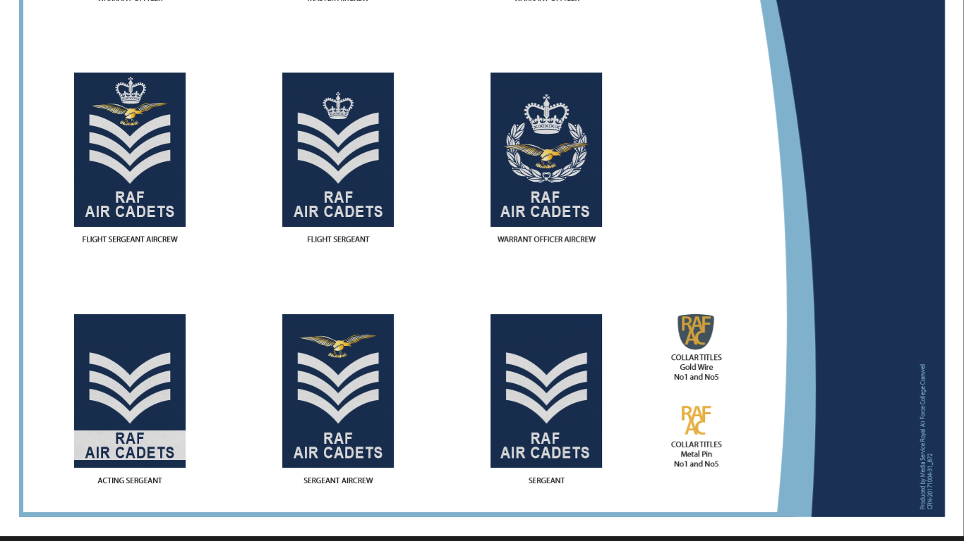

Flight Sergeant Flight Sergeant Aircrew



“Sergeant”



Acting Sergeant Sergeant Sergeant Aircrew