First Aid Quiz 19

Foreign objects (to do with First Aid, not what might be found on the runway)

What does Foreign Objects mean to you when thinking of First Aid? …………………………………..

………………………………………………………………………………………………………………………….

Or draw a line from the Foreign Object to the body part.

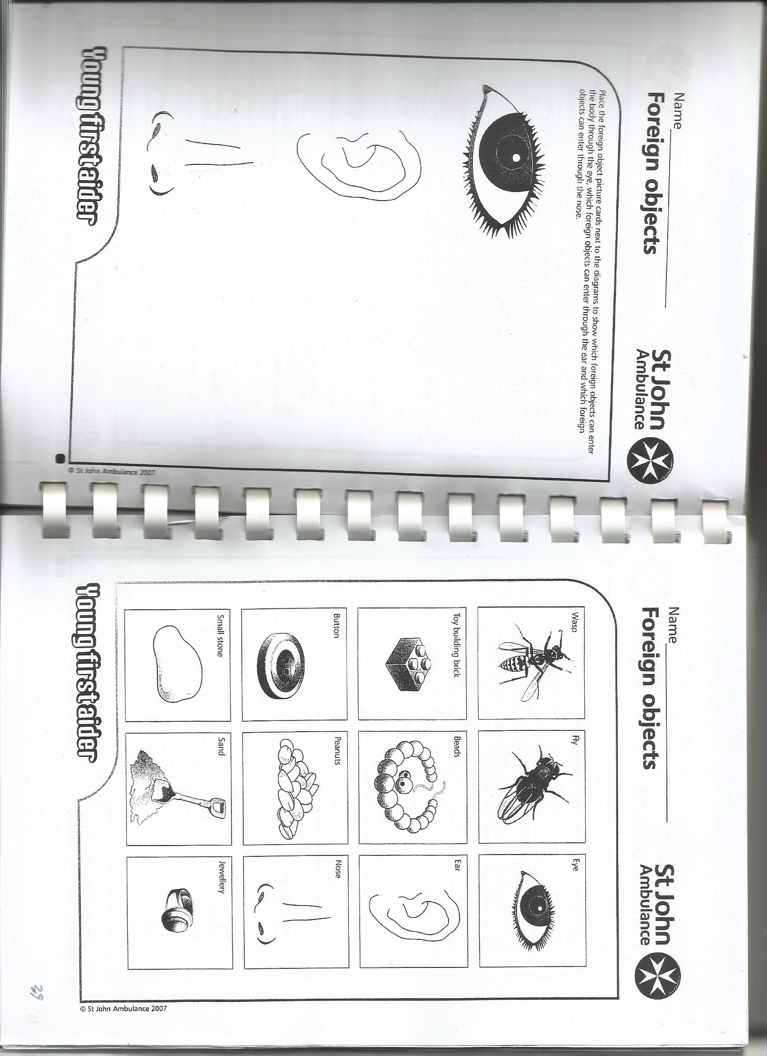You can add some of your own ideas for the foreign objects, 3 boxes are provided.

Then go to p2 to give more detail.





For each of the foreign objects write why it is a problem and how it can be removed:

**Wasp**

How is a problem: ……………………………………………………………………………………………….

How is removed: ……………………………………………………………………………………………….

**Fly**

How is a problem: ……………………………………………………………………………………………….

How is removed: ……………………………………………………………………………………………….

**Button**

How is a problem: ……………………………………………………………………………………………….

How is removed: ……………………………………………………………………………………………….

**Peanuts**

How is a problem: ……………………………………………………………………………………………….

How is removed: ……………………………………………………………………………………………….

**Jewelery**

How is a problem: ……………………………………………………………………………………………….

How is removed: ……………………………………………………………………………………………….

**Toy building block**

How is a problem: ……………………………………………………………………………………………….

How is removed: ……………………………………………………………………………………………….

**Beads**

How is a problem: ……………………………………………………………………………………………….

How is removed: ……………………………………………………………………………………………….

**Small stone**

How is a problem: ……………………………………………………………………………………………….

How is removed: ……………………………………………………………………………………………….

**Sand**

How is a problem: ……………………………………………………………………………………………….

How is removed: ……………………………………………………………………………………………….

**Your idea 1**

How is a problem: ……………………………………………………………………………………………….

How is removed: ……………………………………………………………………………………………….

**Your idea 2**

How is a problem: ……………………………………………………………………………………………….

How is removed: ……………………………………………………………………………………………….

**Your idea 3**

How is a problem: ……………………………………………………………………………………………….

How is removed: ……………………………………………………………………………………………….