First Aid Quiz 19

Foreign objects (to do with First Aid, not what might be found on the runway)

What does Foreign Objects mean to you when thinking of First Aid? …………………………………..

………………………………………………………………………………………………………………………….

Or draw a line from the Foreign Object to the body part.

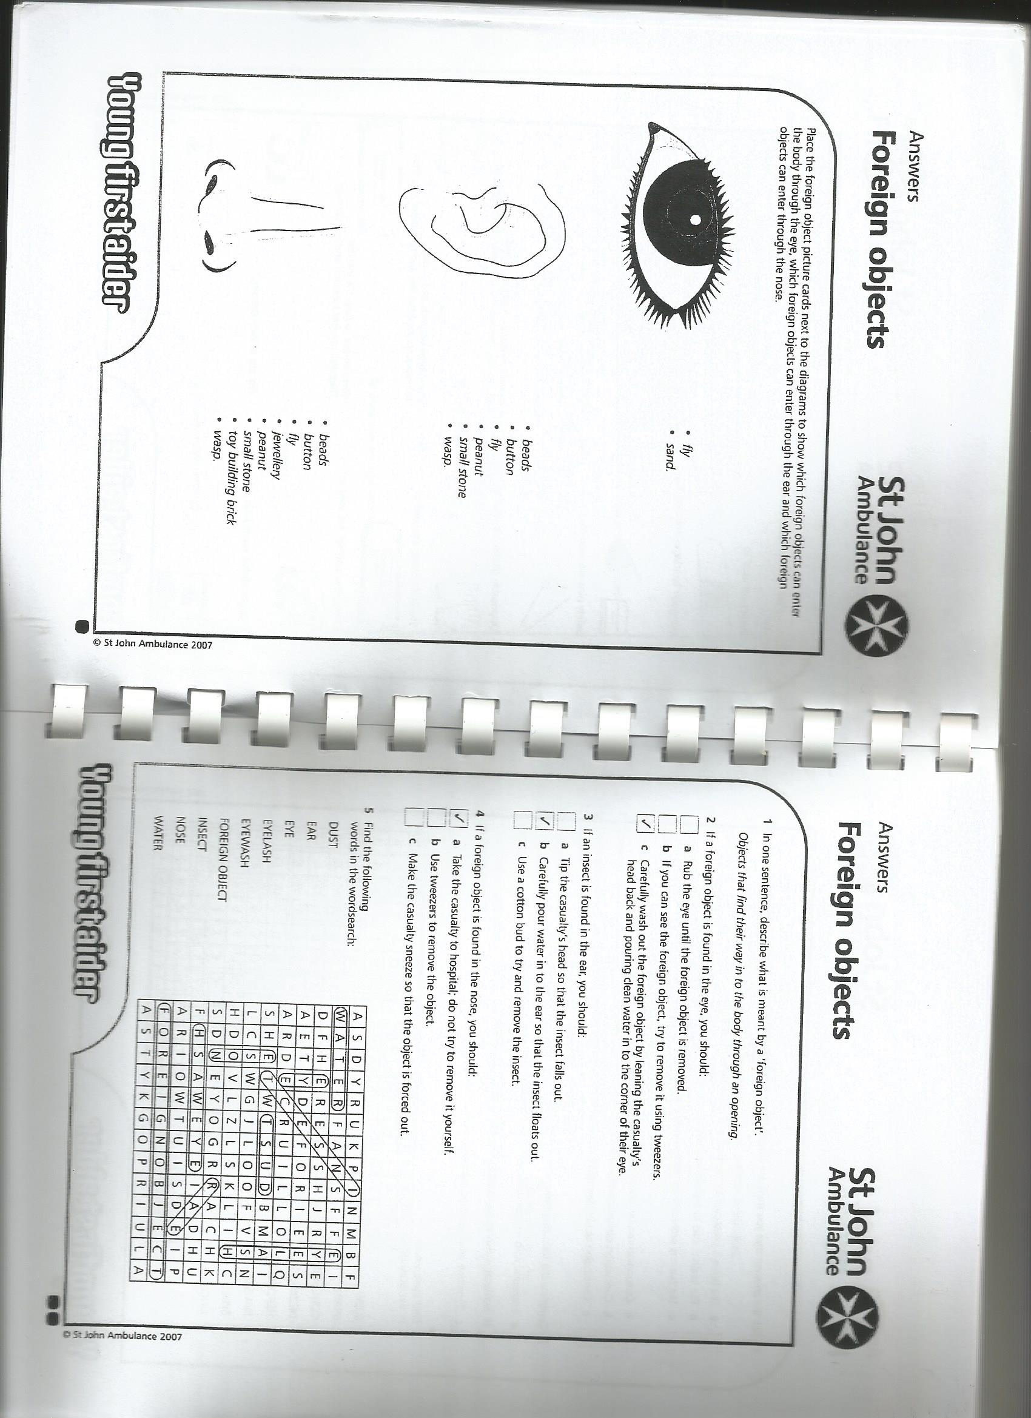

You can add some of your own ideas for the foreign objects, 3 boxes are provided.

Then go to p2 to give more detail.

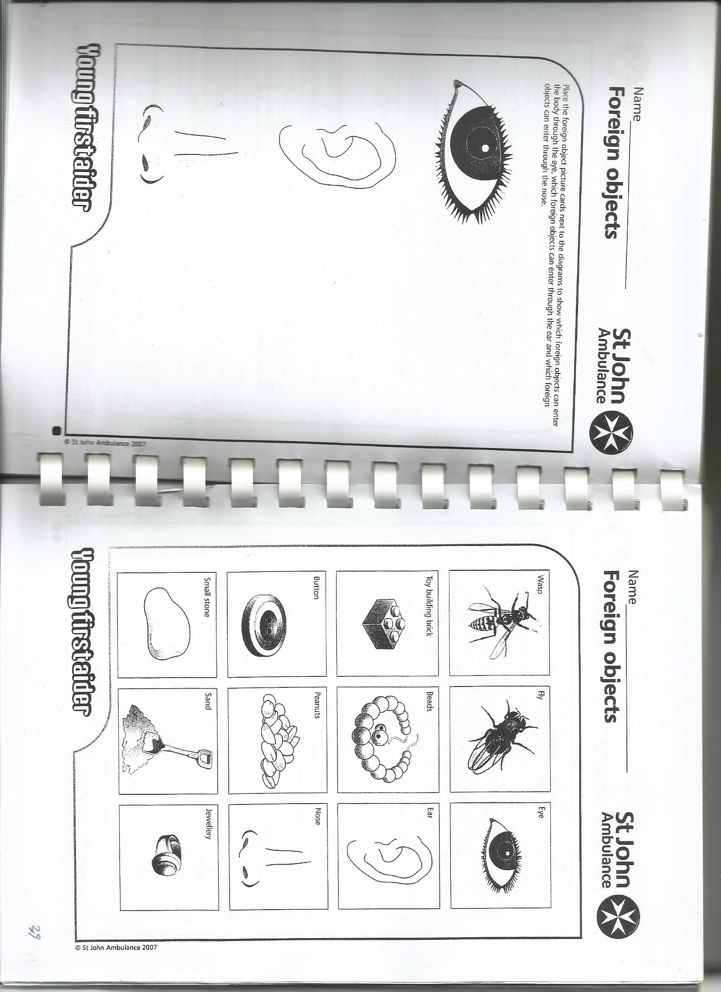



For each of the foreign objects write why it is a problem and how it can be removed:

*IN ALL CASES: IN THE NOSE TAKE TO HOSPITAL, IN EYE OR EAR TRY FLUSHING OUT, IF THIS DOES NOT WORK THEN TAKE TO HOSPITAL*.

**Wasp**

How is a problem: *Can block breathing in the nose, can sting,*

How is removed: ……………………………………….

**Fly**

How is a problem: *Block breathing in the nose, discomfort in the eye, affect sight, affect hearing in ear*

How is removed: ……………………………………………………………………………………………….

**Button**

How is a problem: *Can block breathing in the nose, affect hearing in ear,*, #

How is removed: ……………………………………………………………………………………………….

**Peanuts**

How is a problem: *Can block breathing in the nose, affect hearing in ear, can cause severe allergy*

How is removed: *Plus check for epipen, get to hospital* ……………………………….

**Jewelery**

How is a problem: *Can block breathing in the nose, affect hearing in ear,*

How is removed: ……………………………………………………………………………………………….

**Toy building block**

How is a problem: *Can block breathing in the nose, affect hearing in ear,*

How is removed: ……………………………………………………………………………………………….

**Beads**

How is a problem: *Can block breathing in the nose, affect hearing in ear,*

How is removed: ……………………………………………………………………………………………….

**Small stone**

How is a problem: *Can block breathing in the nose, affect hearing in ear,*

How is removed: ……………………………………………………………………………………………….

**Sand**

How is a problem: *Can block breathing in the nose, irritation in the eye with inflammation*

How is removed: ……………………………………………………………………………………………….

**Your idea 1**

How is a problem: ……………………………………………………………………………………………….

How is removed: ……………………………………………………………………………………………….

**Your idea 2**

How is a problem: ……………………………………………………………………………………………….

How is removed: ……………………………………………………………………………………………….

**Your idea 3**

How is a problem: ……………………………………………………………………………………………….

How is removed: ……………………………………………………………………………………………….