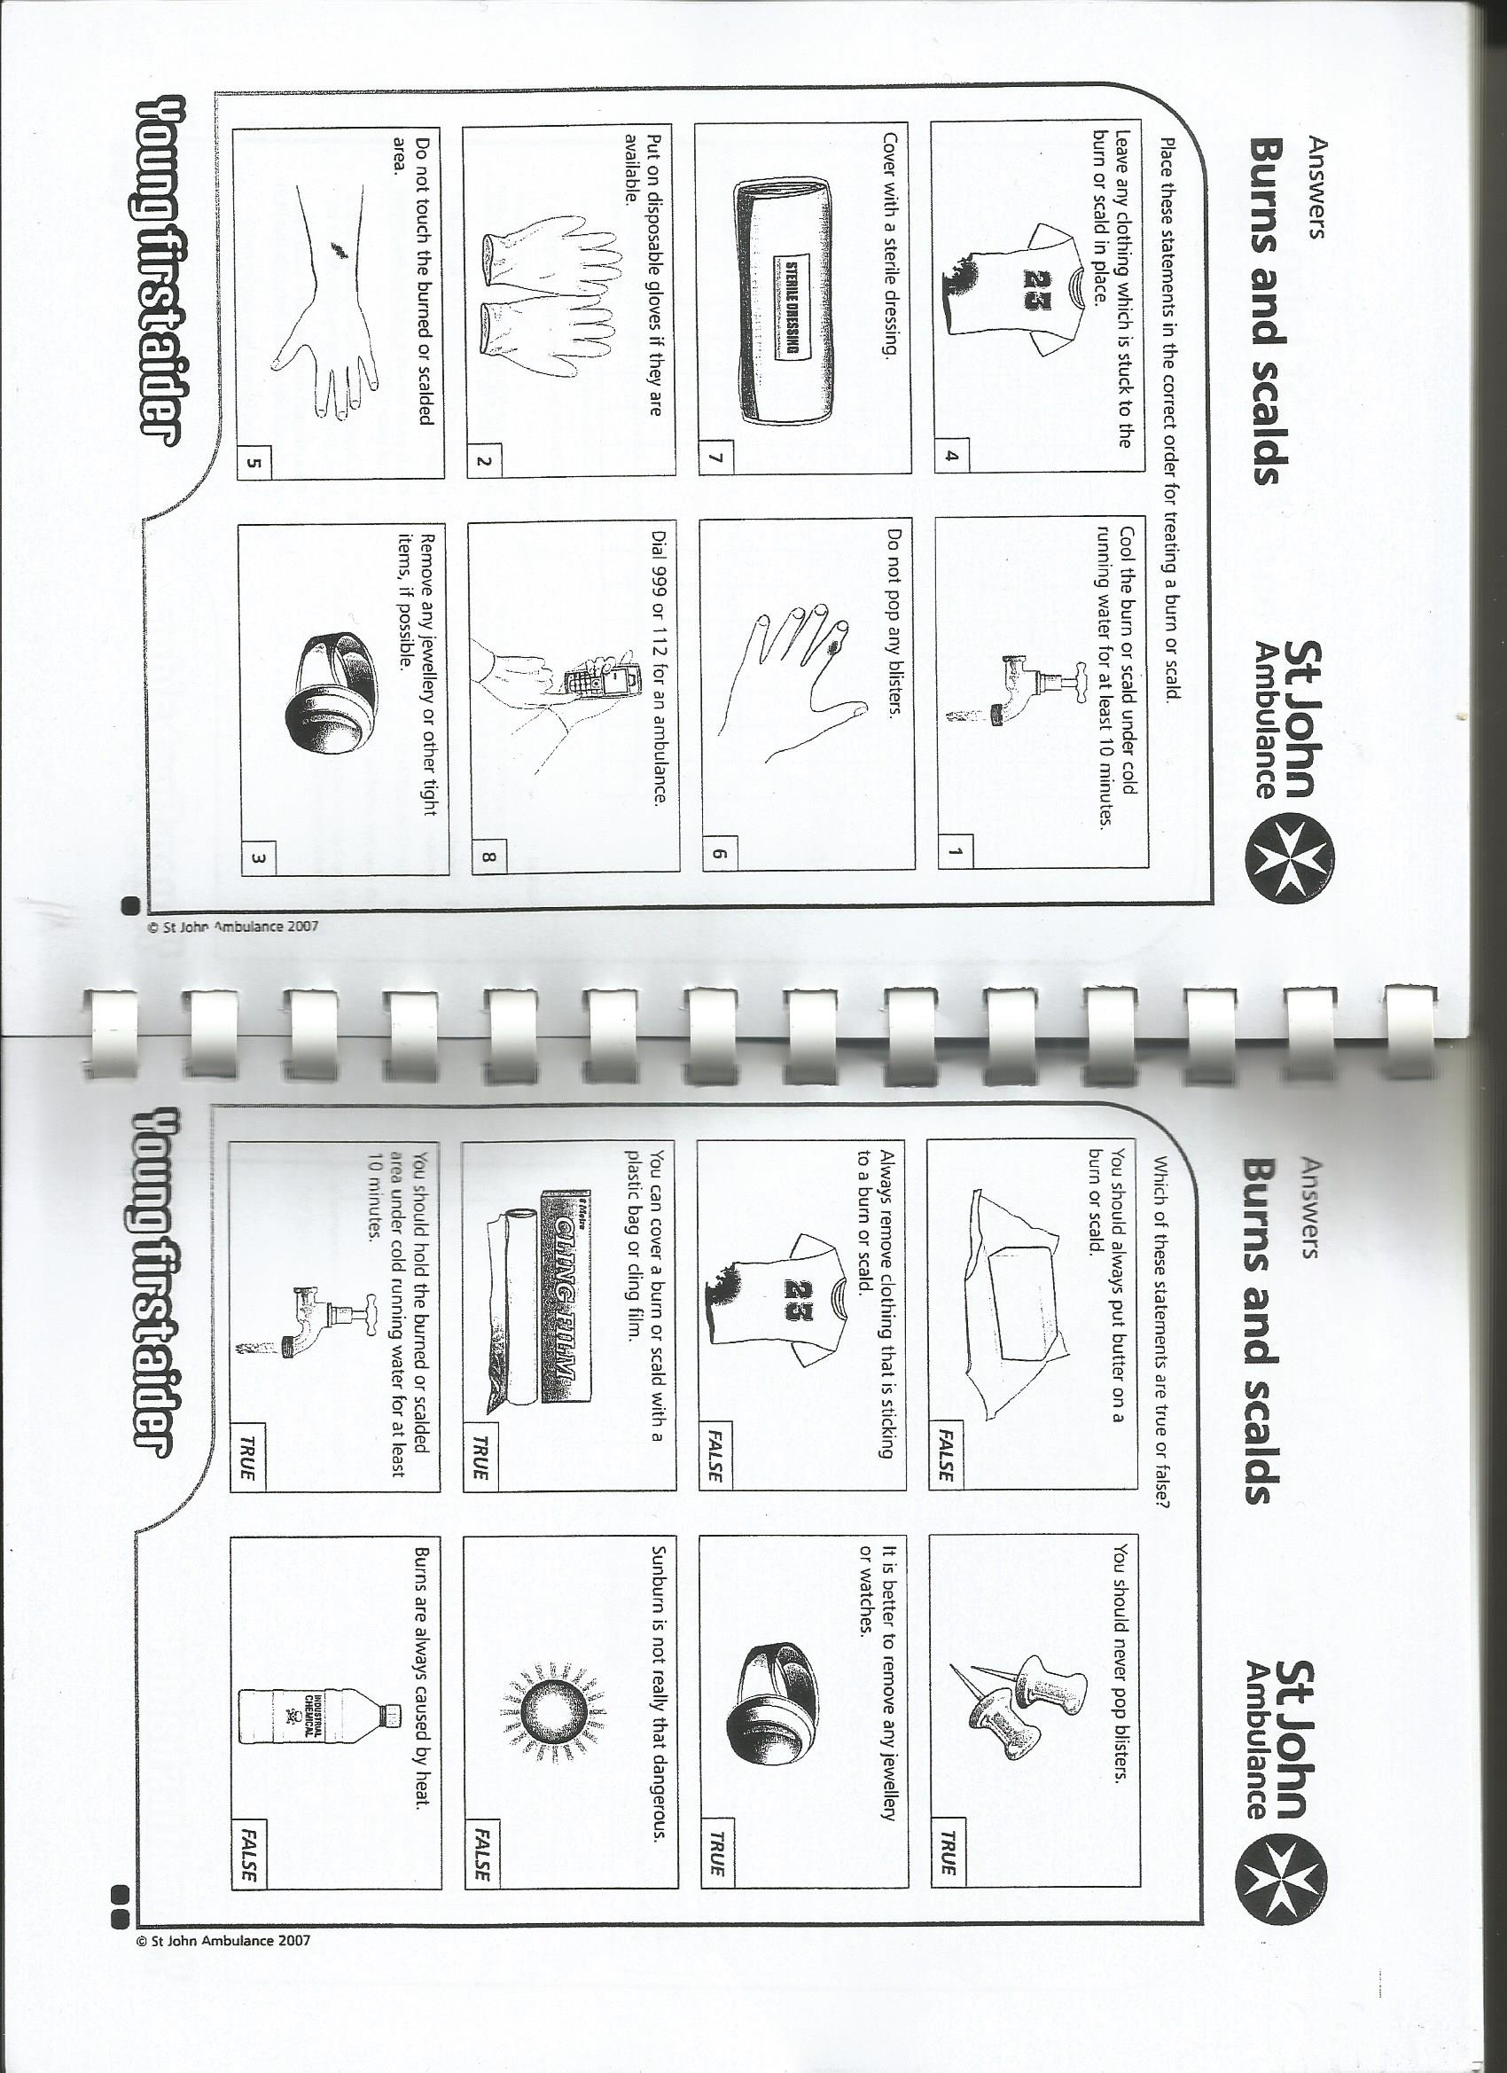First Aid Quiz 37, Answers

Burns and Scalds 2

2

1

4

5

6

8

7

Explain your answers:

1. *The butter does not cool the burn or scald down.*

2. *Popping a blister would let infection in.*

3. *Removing clothing sticking to the skin would tear the skin, make it worse and let in infection.*

4. *Burns and scalds can cause swelling, watches and jewellery could get stuck, make swelling worse.*

5. *Plastic bag or cling film, if clean, can keep the wound clean without sticking to it.*

3

6. *Sunburn can very dangerous, weakening the skin and can lead to melanoma, skin cancer.*

7. *Running cold water helps cool the burnt or scalded area and reduces swelling.*

8. *Some chemicals can burn, there can also be cold burns from ice.*